Minimum/Maximum Problems

1. A 1000 m track is to be build with two straight sides and semicircles at the ends.
a) Find the dimensions of the track that encloses the maximum area. [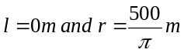]
b) Find the dimensions of the track that encloses the maximum rectangular area. [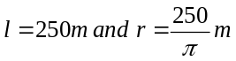]

2. The height of an object above the ground is given by the equation 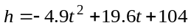where the height h is measured in meters, and the time t in seconds.
a) What is the initial height of the object? [104 m]
b) What would be the maximum height of the object and when this will happen? [123.6 m at 2 s]
c) How much time it would take for the object to reach the ground? [7 s]
d) How much time would the object be at a height more than 50 m from the ground? [5.88 s]

3. A farmer wants to make a rectangular corral along the side of a large barn and has enough materials for 60 m of fencing. Only three sides must be fenced, since the barn will form the fourth side. What dimensions (length and width) of the rectangle should the farmer use so that the maximum area is enclosed? What is the value of the maximum area? [30 m by 15 m, 4500 m²]

4. The path of the golf ball can be modelled by the function 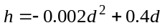 where h is the height of the ball, in meters, and d is the horizontal distance the ball travels, in meters, until it first hits the ground.
a) What is the maximum height reached by the ball? [20 m]
b) What is the horizontal distance of the ball from the golfer when the ball reaches its maximum height? [100 m]
c) What distance does the ball travel horizontally until it first hits the ground? [200 m]

5. The Environmental Club sells sweatshirts as a fundraiser. They sell 1200 shirts a year at $20 each. A survey indicates that, for every $2 increase in price, there will be a drop of 60 sales a year. What should the selling price be in order to maximize the revenue? What would be the maximum value of the revenue?
[ $30, $27,000]]

6. Find the side length of the rectangle with the biggest area that can be inscribed in a circle of radius 10.
[14.14]

7. The sum of two numbers is 10. Find the maximum product of these numbers.
[25]

8. Find the dimensions (length and width) of a rectangle that is inscribed in a right triangle with the base equal to 3 and a height equal to 4 and has a maximum area.
[1.5 by 2]

9. Find the dimensions of the largest right-cylinder that can be inscribed in a sphere of radius 10.
[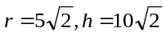]

10. The product of two positive numbers is 10. Find the minimum sum of these numbers.
[

